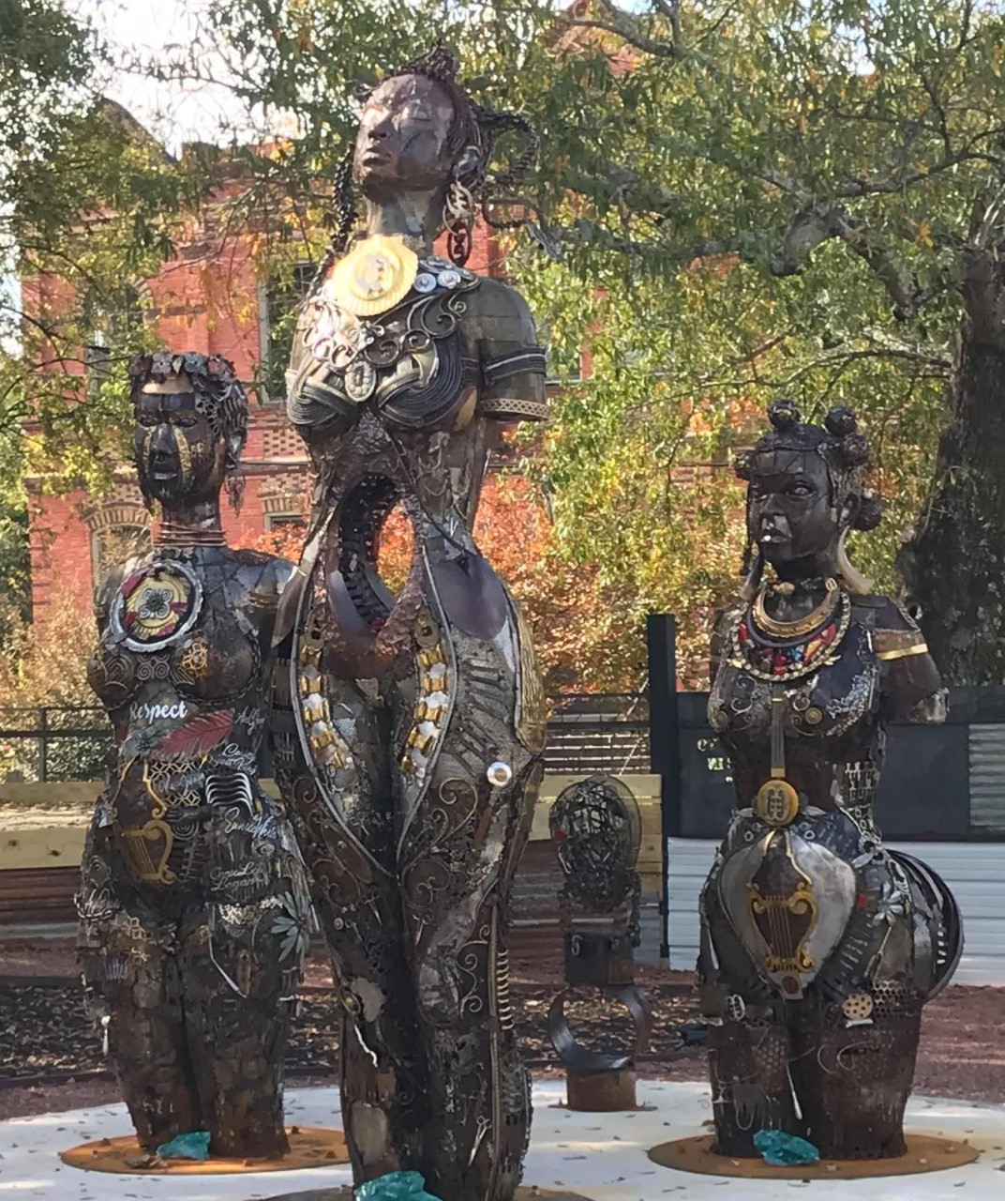

The Mothers of Gynecology

Anarcha
Lucy
Betsey

#SayTheirNames

A sculpture by Michelle Browder to honor three of the enslaved Black women James Marion Sims (1813-1883) did experimental gynecological surgeries on without anesthesia or consent.

Tributes to Sims have been removed in both Philadelphia and New York but he is still honored at the State Capital of Alabama as the Father of Modern Gynecology and a ‘benefactor of women’ though clearly the victims of his experiments are erased by that assessment.

#TakeSimsDown

